# HOW TO DEPLOY SHINY APP IN SHINY.IO?

Before you get started with shinyapps.io, you will need:

• A Python development environment, like VS Code

• The rsconnect-python Python package from PyPI, or the latest version from GitHub

To install rsconnect-python in your local Python environment process, you can run the following command on the terminal:

**pip install rsconnect-python**

If you would like the use the latest version of rsconnect-python, you can install it with the following command in your terminal:

pip install git+https://github.com/rstudio/rsconnect-python.git

## Creating a shinyapps.io account

Go to shinyapps.io and click “Log In”. The site will give you several options for signing in. If you have a Google account or a GitHub account, you can use either one of those methods to authenticate. Alternatively, you can create a username/password combination.

The first time you sign in, shinyapps.io prompts you to set up your account. Shinyapps.io uses the account name as the domain name for all of your apps. Account names must be between four and 63 characters and can only contain letters, numbers, and dashes (-). Account names may not begin with a number or a dash, and they cannot end with a dash (see RFC 952). Some account names may be reserved.

## Deploying applications

### Configure rsconnect-python

Once you have set up your account in shinyapps.io and installed rsconnect-python locally, you can configure the rsconnect-python package to use that account. Shinyapps.io automatically generates a token and secret for you, which the rsconnect-python package can use to access your account. Retrieve your token from the shinyapps.io dashboard by selecting the Tokens option in the menu at the top right of the shinyapps dashboard (under your avatar). 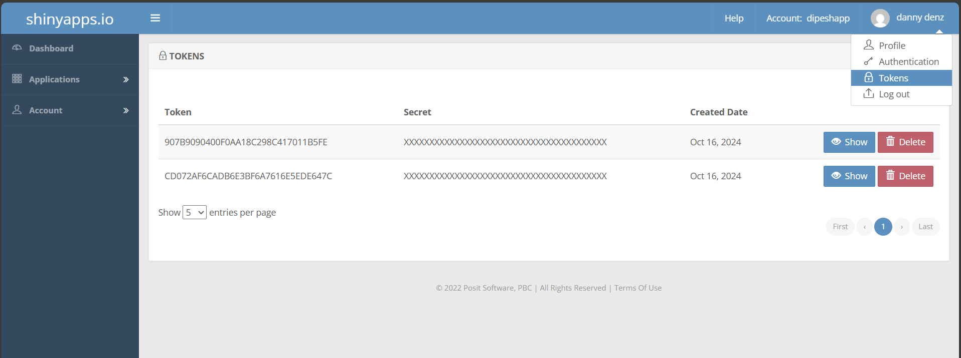

Click the Show button on the Token page. A window will pop up that shows the full command to configure your account using the appropriate parameters for the rsconnect add command. Copy this command to your clipboard, and then paste it into your terminal and run it.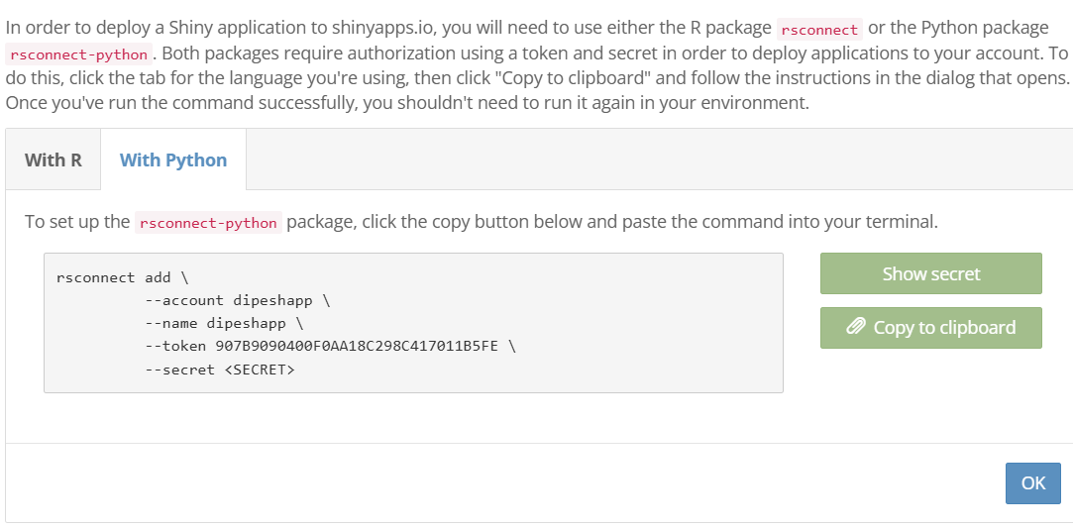

**Developing a Shiny app**

Once you have created your application, it can be deployed to shinyapps.io by using the rsconnect-python package with the following command in your terminal:

rsconnect deploy shiny /path/to/app --name <NAME> --title my-app

Replace /path/to/app with the location of your app, <NAME> with your shinyapps.io account name, and my-app with your desired app title.

Note:

1. while giving /path/to/app write within “ “ . For example “E:\d file\APP TEST”
2. Include all the library needed for the shiny app in “requirements.txt” and while saving the file you must save in UF-8 encoding to avoid the error.

Visit <https://docs.posit.co/shinyapps.io/guide/getting_started/> for in-depth information about how to deploy a Shiny application using Python.